User Manual for RNAFind

**Introduction:**

RNAFind is an easy to use command line tool that allows users to input a list of RNA genes, including mRNAs, miRNAs, and other ncRNAs such as lncRNAs. The user specifies the list of RNA genes in a config file and the program finds all RBPs that bind the specified genes. The user is then able to perform multiple forms of analysis, such as visualization of the RBPs that bind the genes (on UCSC genome browser), binding correlation analysis between multiple RBPs, and visualization of the Cooperation-Competition graph with respect to a specified RBP’s binding sites.

**Requirements:**

The user needs the following Python modules installed:

* Pandas
* Pyperclip
* SortedContainers

**Interface Summary:** 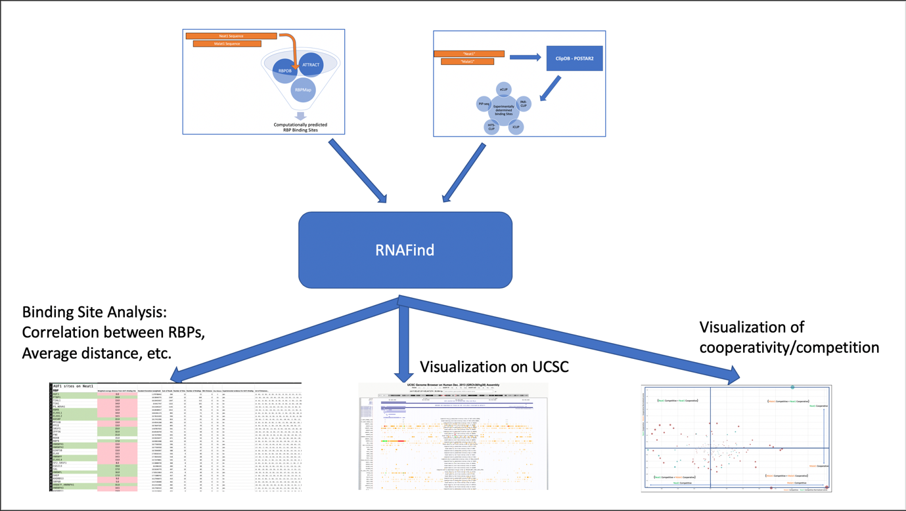

Experimentally verified RBP binding sites

Computationally predicted RBP binding sites

RNAFind takes two forms of inputs that gives it information on where RNA binding proteins (RBPs) bind on a selected list of RNA molecules. The program then uses the information to allow the user to perform multiple forms of analyses, such as correlational binding analysis between multiple RBPs on any given RNA molecule, visualization of the RBP bidning sites on any given RNA molecule (including summary bindings of multiple RBPs), and Cooperation-Competition graph of any RBP with the rest of RBPs given two RNA molecules of interest

**Input:**

Computationally predicted RBP binding sites

Experimentally verified RBP binding sites

**Output:**

Binding Site Analysis

UCSC Browser Visualization

Cooperation-Competition Graph